Project Design Phase-II
Data Flow Diagram & User Stories

Date | 6 April 2026
Team ID | SWTID-2026-9601
Project Name | Smart library request workflow
Maximum Marks | 4 Marks

Data Flow Diagrams:
A Data Flow Diagram (DFD) represents how data moves within the Smart Library Request Workflow system. It shows the interaction between the user and the librarian along with the processes involved in handling a book request. In this system, the user submits a request for a book, which is then validated by checking user details and eligibility. The system verifies the availability of the requested book in the inventory. Based on this, the librarian reviews and either approves or rejects the request. Finally, the system notifies the user about the request status. Thus, the DFD helps in clearly understanding the flow of information and ensures an efficient and organized library management process.

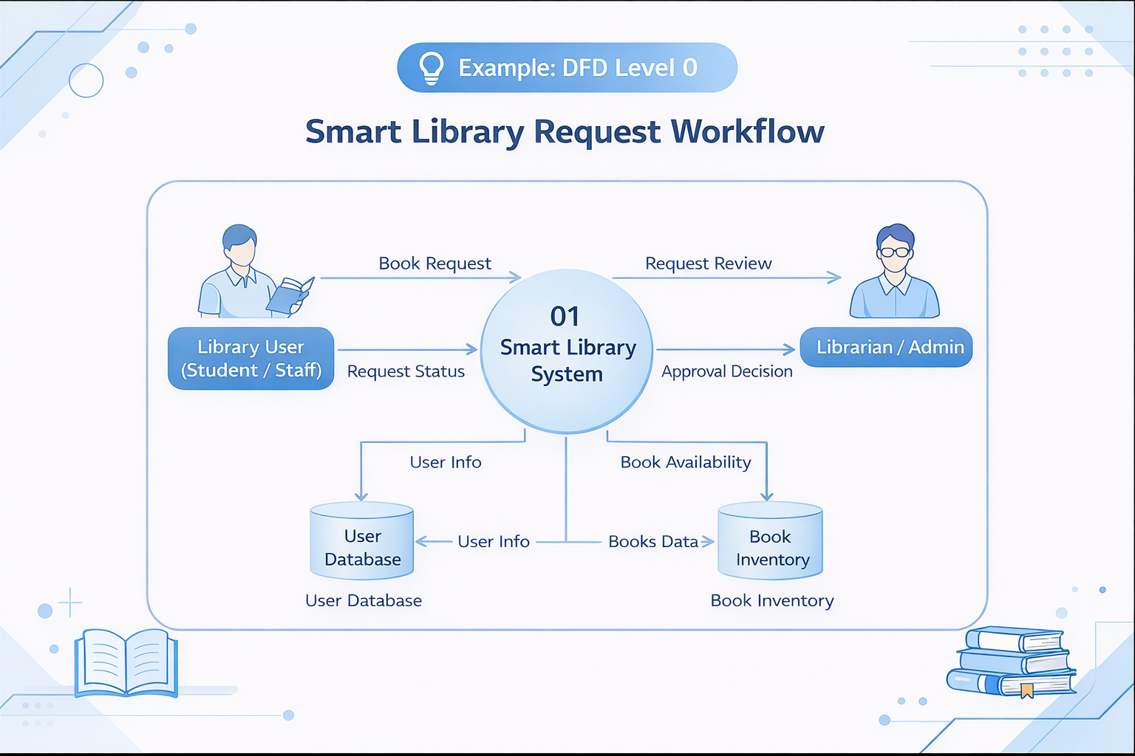
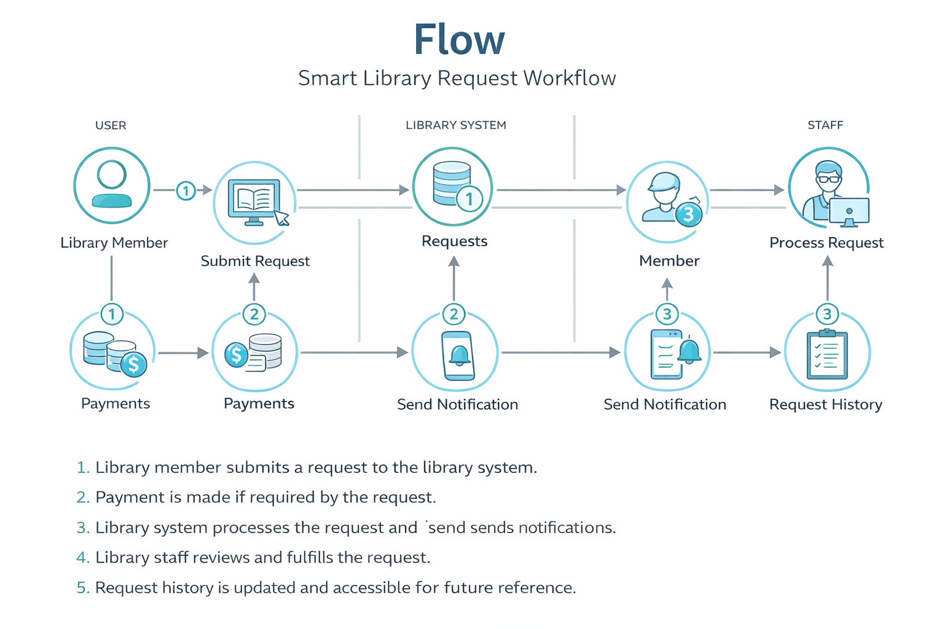

User Stories
Use the below template to list all the user stories for the product.
User Type | Functional Requirement (Epic) | User Story Number | User Story / Task | Acceptance criteria | Priority | Release
Customer (Mobile user) | Registration | USN-1 | As a user, I can register using email and password. | User can successfully create an account and access dashboard. | High | Sprint-1
 |  | USN-2 | As a user, I receive a confirmation email after registration. | User receives email and can verify account. | High | Sprint-1
 |  | USN-3 | As a user, I can register using Google account. | User can sign up/login via Google. | Medium | Sprint-1
 |  | USN-4 | As a user, I can register using social media (Facebook). | User can access account through Facebook login. | Low | Sprint-2
 | Login | USN-5 | As a user, I can register using social media (Facebook). | User can securely log into the system. | High | Sprint-1

